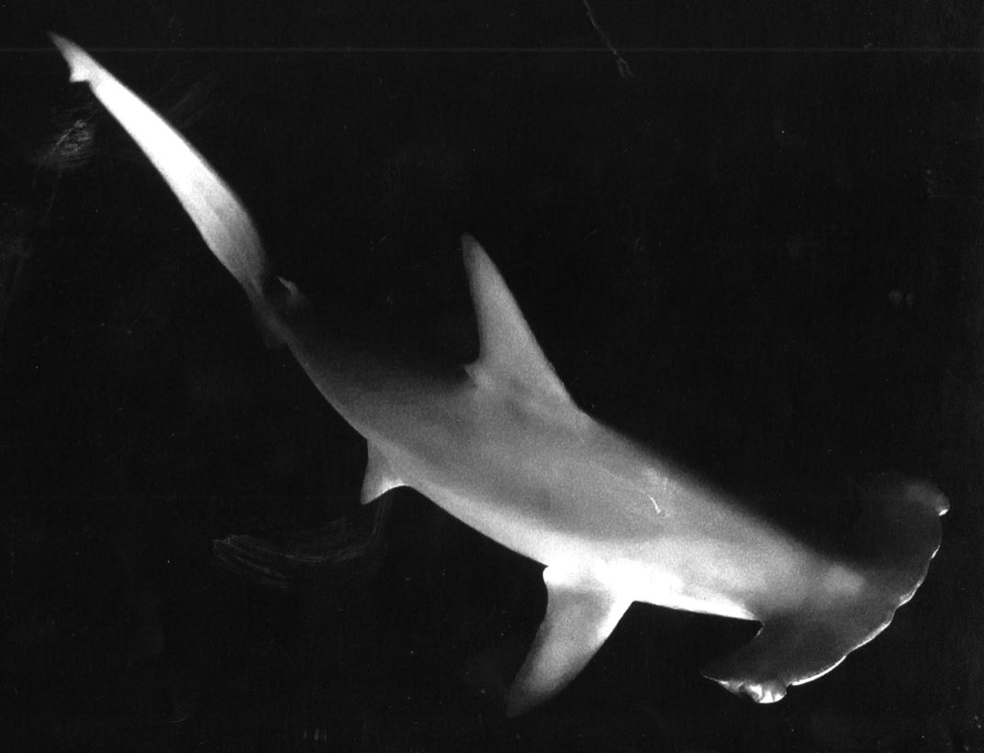
SOLIHULL SUB AQUA CLUB (SSAC)

Minutes of Committee Meeting 19th April 2019

Contents
1 Attendance 3
2 Actions from Previous Meeting 3
3 Chairman’s Report 3
4 Treasurer’s Report 3
5 Diving Officer’s Report 3
6 Training Officer’s Report 4
7 Club Secretary’s Report 4
8 Club Admin 4
9 A.O.B 4
10 Next Meeting 4

Attendance
Present:
Louisa Langley Secretary
Mahyar Barad Diving Officer
Di Huxley Training
Lynne Daniels Membership

Apologies
Mick White Chairman
Dave Biggs Treasurer

Actions from Previous Meeting

Chairman’s Report

Treasurer’s Report

Diving Officer’s Report

Training Officer’s Report

Club Secretary’s Report

Club Admin

A.O.B

Next Meeting

